Day 27 – Text Preprocessing

Tokenization :

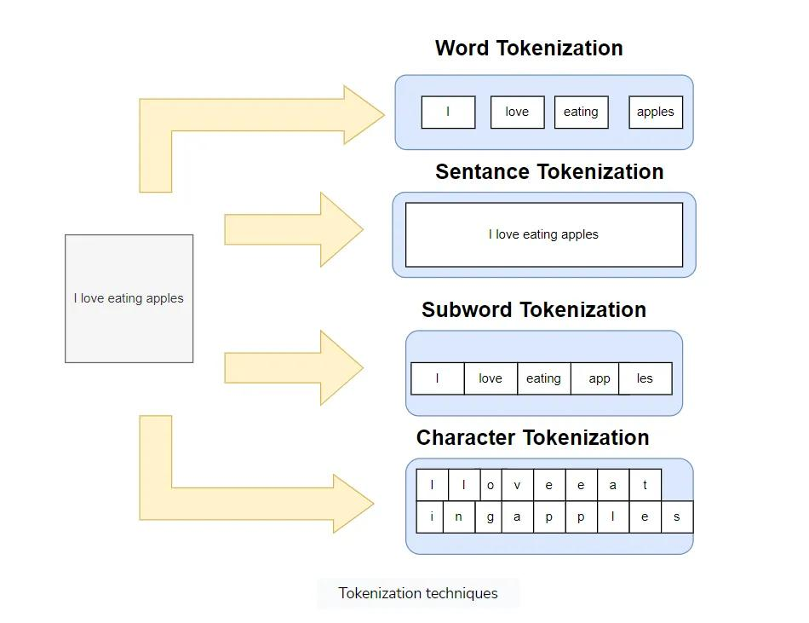
Tokenization = splitting text into smaller units (tokens)

1. Word Tokenization
Word tokenization is the most commonly used method where text is divided into individual words. It works well for languages with clear word boundaries, like English. For example, "Machine learning is fascinating" becomes:

Input before tokenization: ["Machine Learning is fascinating"]
Output when tokenized by words: ["Machine", "learning", "is", "fascinating"]

2. Character Tokenization
In Character Tokenization, the textual data is split and converted to a sequence of individual characters. This is beneficial for tasks that require a detailed analysis, such as spelling correction or for tasks with unclear boundaries. It can also be useful for modelling character-level language.
Example

Input before tokenization: ["You are helpful"]
Output when tokenized by characters: ["Y", "o", "u", " ", "a", "r", "e", " ", "h", "e", "l", "p", "f", "u", "l"]

3. Sub-word Tokenization
This strikes a balance between word and character tokenization by breaking down text into units that are larger than a single character but smaller than a full word. This is useful when dealing with morphologically rich languages or rare words.
Example
["Time", "table"]
["Rain", "coat"]
["Grace", "fully"]
["Run", "way"]
Sub-word tokenization helps to handle out-of-vocabulary words in NLP tasks and for languages that form words by combining smaller units.

4. Sentence Tokenization
Sentence tokenization is also a common technique used to make a division of paragraphs or large set of sentences into separated sentences as tokens. This is useful for tasks requiring individual sentence analysis or processing.
Input before tokenization: ["Artificial Intelligence is an emerging technology. Machine learning is fascinating. Computer Vision handles images. "]
Output when tokenized by sentences ["Artificial Intelligence is an emerging technology.", "Machine learning is fascinating.", "Computer Vision handles images."]

Stopwords:
Stopwords = very common words that carry little meaning
Stop words are common words (e.g., “the,” “is,” “and”) that are often removed during NLP tasks as they don’t carry significant meaning.
in our pre-processing pipeline, we would probably remove these words to let our model focus on the words that may indicate something more exceptional.
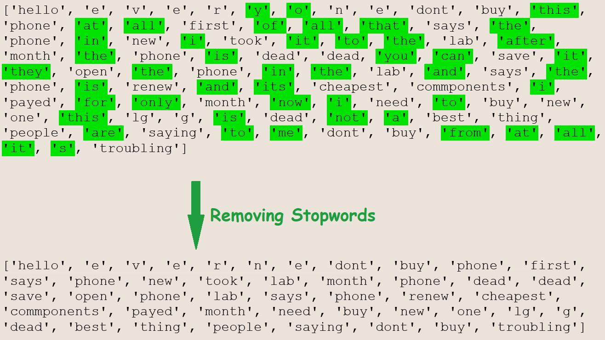

Stemming :
Stemming is a technique in Natural Language Processing (NLP) used to reduce words to their base or root form. It removes suffixes and prefixes to simplify words while preserving their core meaning. For example, words like “running,” “runs,” and “runner” are reduced to the root form “run.”
Stemming helps in text processing by ensuring that variations of a word are treated as the same entity, improving tasks like search engines, text classification, and sentiment analysis. However, stemming is sometimes imprecise, as it may cut off too much or fail to capture the true base form.

Lemmatization:
Lemmatization = converting words to their base (dictionary) form
Lemmatization is a more advanced and accurate form of text normalization compared to stemming. Instead of simply chopping off word endings, lemmatization considers the word’s meaning and part of speech to reduce it to its base or root form (lemma), ensuring the word retains its meaning. For example, it converts “running” to “run” and “better” to “good,” unlike stemming which might incorrectly convert “running” to “runn.”
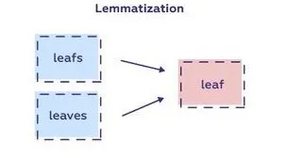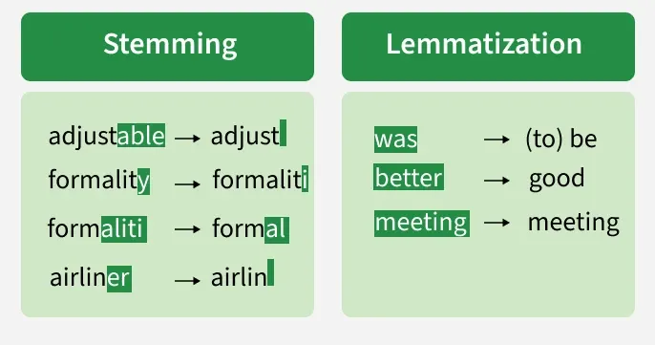

Key Concepts of Lemmatization
- Lemma: The base form of a word. For example, the lemma of “better” is “good,” and the lemma of “was” is “be.”
- Part of Speech (POS): Lemmatization relies heavily on the correct identification of the word’s part of speech, as this affects its base form. For example, “running” could be a verb (“run”) or a noun (“running”), and the lemmatizer will need this information to choose the right lemma.
- Tokenization breaks the sentence into words.
- POS Tagging identifies each word’s part of speech.
- Lemmatization reduces words to their base form (based on part of speech) for more accurate text processing.
- Lemmatization looks up the correct base form of a word in a lexical database, such as WordNet, and determines the appropriate base form based on the context
Lemmatization is useful in NLP tasks like text classification or sentiment analysis to standardize words, helping models better understand the core meaning of words without dealing with various word forms.

Cleaning Pipeline :

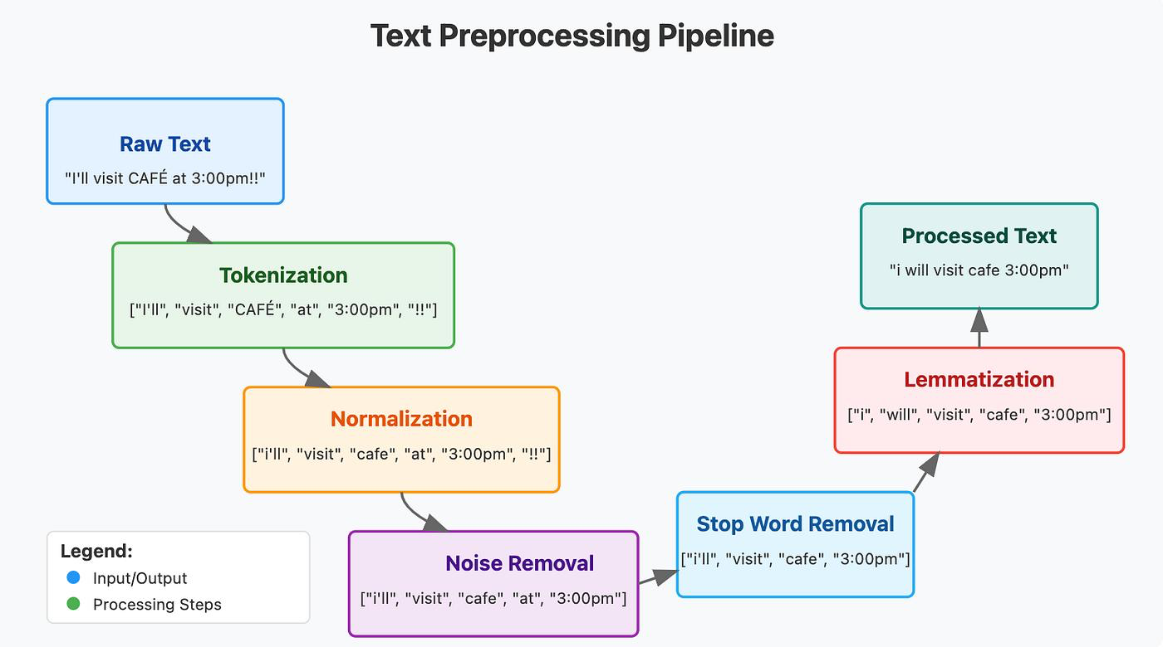

1. Tokenization Breaking a sentence into individual units called tokens — usually words or subwords. It's the very first step because every step after this works on tokens, not the full sentence.
2. Normalization Making tokens consistent. This includes lowercasing everything, removing accents (CAFÉ → cafe), and sometimes expanding contractions (I'll → I will). The goal is that the same word written differently gets treated as one word.
3. Noise Removal Stripping out things that carry no useful information — punctuation, special characters, HTML tags, emojis, extra spaces. They add nothing to meaning but confuse models.
4. Stop Word Removal Words like "the", "is", "at", "of" appear constantly but mean almost nothing on their own. Removing them reduces the size of your data and helps the model focus on words that actually carry meaning.
5. Lemmatization (vs Stemming) Reducing words to their root form. "running", "ran", "runs" all become "run". This is different from stemming, which is a cruder chop (e.g., "running" → "runn"). Lemmatization is smarter because it uses vocabulary context — it gives you a real word, not just a chopped string.

